Briefing Document for AI-ML / GenAI Powered Post-Race Media Optimiser

Following the first phase of the Jaguar TCS Racing x TCS Commercial Technology Consultancy Project, TCS has conducted a thorough assessment of the commercial team’s operations and has produced a full report stating their findings. The report contained proposed solutions on where TCS’s services or products could improve existing challenges or inefficiencies within the commercial team.
As a result of the findings, Jaguar TCS Racing and TCS have agreed to consider a collaboration to develop and integrate the Post-Race Media Optimiser solution with the aim of automating the curation, scoring, tagging and publishing of post-race media assets; and generating new partnership storytelling and content opportunities.
This document will specifically outline the proposed tool development and integration phase in the Jaguar TCS Racing x TCS Commercial Technology Consultancy Project, where we will agree upon the terms to embed the proposed solution into the Jaguar TCS Racing commercial team. The final collaboration will be subject to agreed terms and until then, the parties are not bound by these proposals save that the discussions and these proposals are confidential information and accordingly subject to confidentiality terms.
Project Objectives and Success Metrics
- TCS and Jaguar TCS Racing to agree on project brief including start date, deliverables and timelines prior to TCS beginning the development of the Post-Race Media Optimiser tool.
- TCS to develop an AI-ML/GenAI-powered Post-Race Media Optimiser solution that automates the curation, scoring, tagging, and publishing of post-race media assets (photos, videos, audio). The system will leverage computer vision, NLP, and generative AI to improve storytelling efficiency, PR comms, sponsor visibility, and content impact across social, press, and internal platforms.
- Following the implementation of the tool, TCS and Jaguar TCS Racing will agree on the externally facing messaging of this project in order to identify and pursue partnership storytelling and content opportunities.
- The tool will be used by Jaguar TCS Racing commercial teams, specifically, but not exclusively Partnerships, PR, Digital, Communications, Events and Sales teams to help make effective, data-driven decisions with regards to the media assets curated post-race.

Key Stakeholders
TCS
- This project will require one full-time GenAI Developer and one full-time Media Workflow Analyst to manage the end-to-end development and integration of the tool. Each person will require access to JLR devices in order to successfully share data and migrate the solution over to Jaguar TCS Racing.
- Each person will need to have a thorough understanding of the project brief, and the background to the project to ensure the objectives and goals are achieved.
- Each person will be responsible for ensuring the project is delivered on time as per the agreed timeline, or otherwise clearly communicate possible delays to the project to Jaguar TCS Racing.
- TCS will be responsible for ensuring the smooth migration of the Post-Race Media Optimiser tool, including the facilitation of an onboarding session with Jaguar TCS Racing to educate users on the functionality of the tool.
- All costs associated with this project will be provided free of charge by TCS, including the ongoing management and monitoring of the solution once embedded.
Jaguar TCS Racing Partnerships Team
- Will work with TCS to facilitate the development and integration of the Post-Race Media Optimiser tool into the Jaguar TCS Racing commercial team.
- Will collate and provide TCS with timely feedback from relevant internal stakeholders to help inform the development of the Post-Race Media Optimiser tool
- Will provide the relevant access to the existing systems and/or platforms that the Post-Race Media Optimiser tool will integrate with, subject to sensitivities and availabilities.

Key Capabilities:
- Media Clustering: Automatically group media assets into themes (e.g., podium, fan reactions, driver highlights).
- Asset Scoring: Evaluate assets based on sponsor visibility, emotional resonance, lighting, and context.
- GenAI Captions & Summaries: Generate sponsor-ready social/PR copy and summaries.
- NLP & Speaker Insight: Extract quotes and sentiment from race-day audio using speech-to-text + NLP.
- DAM Integration: Direct publishing, tagging, and metadata handover to SharePoint/Imagen.
- Performance Benchmarking: Predict and compare media effectiveness post-publication.

Deliverables
Deliverables – Post-Race Media Optimiser Project
1. AI-ML / GenAI Powered Web-Based Application
1.1. Core Web Platform Development
1.1.1. Design and development of a secure, role-based web application that enables Jaguar TCS Racing commercial teams to curate, score, tag, and publish post-race media assets.
1.1.2. The tool/platform will be cloud-hosted (depending on infrastructure resource availability), responsive, and scalable to handle race-day media volumes.
Review & Approvals : Environment and infrastructure readiness confirmation from Jaguar TCS Racing IT prior to deployment (Week 6).
1.2. AI/ML & GenAI Processing Modules
1.2.1. Development of integrated modules for media clustering, sponsor/logo detection, emotion analysis, caption generation, and media scoring.
Joint Review: Joint review with Jaguar TCS Racing for model training datasets, sponsor repository, and campaign metadata (Weeks 5).
1.2.2. Built on scalable architecture to allow future model enhancements and new feature additions.
Joint Review & Demo: Milestone demo of clustering and scoring engine to Jaguar TCS Racing for feedback prior to integration (Week 6).
1.3. Media Asset Ingestion Module
1.3.1. Implementation of automated ingestion pipelines for photos, videos, and audio files from multiple sources.
1.3.2. Secured storage with metadata extraction for downstream processing.
Joint Review: Jaguar TCS Racing to confirm data ingestion sources and permissions and Security & data governance review with Jaguar TCS Racing (Week 6).
1.4. Workflow UI Module
1.4.1. Delivery of a user-friendly interface that allows real-time preview, curation, and tagging of assets.
1.4.2. Enables reviewers to manage approval workflows efficiently prior to publishing.
Review & Approval: UI/UX prototype walkthrough with Jaguar TCS Racing for workflow module (Week 9).

2. User Authentication & Access Control
2.1. Implementation of SSO-enabled login credentials for authorized Jaguar TCS Racing stakeholders (Partnerships, PR, Digital, Comms, Events & Sales teams).
2.2. Access control will follow JLR’s security standards and role-based permission structure.
Joint Review: Security & Compliance sign-off (Week 9).

3. Sponsor Visibility & Media Scoring Dashboard
3.1. A real-time Content Review Dashboard to visualize clustered media assets, ranked scores, captions, and publishing status.
3.2. The dashboard will support filtering by race, sponsor, priority, channel, and emotional resonance.
Join Review & Approval: Dashboard prototype review and feedback session with Jaguar TCS Racing. UAT and business sign-off after validation of scoring logic and filtering workflows (Week 9).

4. Integration with Existing DAM & Publishing Systems
4.1. Full API-based integration with SharePoint / Imagen to enable seamless tagging, metadata handover, and publishing workflows, in compliance with Jaguar TCS Racing’s internal infrastructure.
Testing & Review : Integration testing and joint go-live readiness review (Week 11).

5. Performance Analytics & Benchmarking Suite
5.1. A built-in Analytics & Monitoring layer to provide post-publication performance tracking, sponsor visibility KPIs, and benchmarking insights to guide content and partnership strategies.
Review & Validation: Analytics model calibration and KPI validation with Jaguar TCS Racing’s Partnerships & Digital teams (Week 11–12).

6. Security, Privacy & Governance Guardrails
6.1. Implementation of RBAC, encryption protocols, GDPR compliance, and audit logging, ensuring responsible AI practices across the tool/platform lifecycle.
6.2. Includes a governance framework for ongoing monitoring and model retraining.
Joint Review: Security and compliance review with Jaguar TCS Racing legal & IT teams and agreement on governance framework and escalation workflows (Week 11).

7. Onboarding & Training Sessions
7.1. TCS will conduct structured onboarding and enablement workshops for end-users and administrators to ensure smooth adoption and effective use of the tool/platform.
7.2. A detailed user manual and quick-start guide will be delivered as part of onboarding.
Joint Review & Sign-off: Pre-onboarding dry run with Jaguar TCS Racing internal champions and documentation sign-off by Jaguar TCS Racing (Week 12).

8. Post-Go-Live Support & Continuous Optimization
8.1. Provision of hypercare support for initial rollout, followed by continuous optimization cycles.
8.2. Includes model tuning, performance enhancements, and on-demand retraining to improve scoring accuracy and content recommendations over time.
Joint Review: Hypercare monitoring review with Jaguar TCS Racing two-weeks post-launch. Quarterly joint optimization checkpoints with Jaguar TCS Racing Partnerships & Digital team (Week 14).

Summary of Approval & Review Timeline
# | Deliverable | Description | Owner | Timeline | Key Output | Review & Approval
1 | AI-ML / GenAI Powered Web-Based Application | Delivery of a secure, cloud-hosted, role-based web application with integrated AI/ML modules for clustering, sponsor/logo detection, emotion analysis, captioning, scoring, and asset workflows. | TCS | Week 6–9 | Fully functional web platform | Environment & infra readiness sign-off (W6); Model & dataset joint review (W5); Milestone demo (W6); Data ingestion & security review (W6); UI/UX approval (W9)
2 | User Authentication & Access Control | SSO-enabled authentication for authorized Jaguar TCS Racing stakeholders, following JLR security standards with RBAC. | TCS | Week 9 | Secure user login with RBAC | Security & compliance sign-off (W9)
3 | Sponsor Visibility & Media Scoring Dashboard | Deployment of a real-time dashboard for visualization of clustered assets, ranked scores, captions, and publishing status. Includes filtering by race, sponsor, priority, channel, and emotional resonance. | TCS | Week 9 | Interactive dashboard UI | Dashboard prototype review & feedback; UAT & business sign-off after scoring logic validation (W9)
4 | Integration with Existing DAM & Publishing Systems | Full API-based integration with SharePoint/Imagen to enable tagging, metadata handover, and publishing workflows. | TCS | Week 11 | Live DAM integration | Integration testing and joint go-live readiness review (W11)
5 | Performance Analytics & Benchmarking Suite | Built-in analytics and monitoring layer for post-publication tracking, sponsor visibility KPIs, and content performance benchmarking. | TCS | Week 11–12 | Analytics & KPI dashboards | Analytics model calibration & KPI validation with Jaguar TCS Racing Partnerships & Digital (W11–12)
6 | Security, Privacy & Governance Guardrails | Implementation of RBAC, encryption, GDPR compliance, and audit logging. Governance framework for ongoing monitoring and model retraining. | TCS | Week 11 | Security-compliant platform | Security & compliance review with legal & IT + governance framework sign-off (W11)
7 | Onboarding & Training Sessions | End-user enablement including structured training workshops, live demos, and delivery of user manuals & quick start guides. | TCS + Jaguar TCS Racing | Week 12 | Training sessions + documentation | Pre-onboarding dry run + documentation sign-off by Jaguar TCS Racing (W12)
8 | Post-Go-Live Support & Continuous Optimization | Hypercare support post-launch including model tuning, performance enhancements, and retraining cycles. | TCS | Week 14 & ongoing | Continuous improvement roadmap | Hypercare monitoring review (2 weeks post-launch); Quarterly joint optimization checkpoints

System Architecture:
- Input Layer: Media ingestion (photos, videos, audio).
- AI Core Layer: Clustering, sponsor/logo detection, emotion analysis, captioning, asset scoring.
- Output Layer: Dashboard for review/approval and API integrations with SharePoint/Imagen.
- Monitoring Layer: Analytics dashboard for performance benchmarking.

Project Development Phases & Timelines:
Phase 1: Discovery & Input Stream Setup (Weeks 1)
- Define ingestion sources (broadcast, on-ground media, social).
- Build sponsor dataset & campaign metadata repository.
- Confirm storage and DAM integration requirements.
Phase 2: Media Processing AI Layer (Weeks 2-3)
- Develop clustering using embeddings.
- Train & fine-tune emotion detection models.
- Create sponsor/logo detection classifiers.
- Integrate Whisper/NLP for quote extraction & sentiment tagging.
Phase 3: Asset Scoring & Ranking (Weeks 3–5)
- Implement scoring logic (sponsor visibility, emotion, lighting, context).
- Normalize & rank assets for priority selection.
Phase 4: GenAI Copywriting Layer (Weeks 5–6)
- Integrate GPT-based captioning & summarization.
- Customize outputs by tone, audience, and sponsor requirements.
- Add alt text generation for accessibility.
Phase 5: Integration with Publishing Tools (Weeks 6-7)
- Build APIs for SharePoint/Imagen metadata tagging & publishing.
- Enable filtering by sponsor, race, priority, and channel.
Phase 6: UI Console Development (Weeks 7-8)
- Develop reviewer/approver dashboard.
- Provide asset preview, filters, and GenAI caption regeneration.
- Role-based access & workflow approvals.
Phase 7: Testing & QA (Weeks 8-10)
- Unit & integration testing across all modules.
- Validate GenAI content (quality, tone, sponsor compliance).
- Security, privacy, and performance testing.
Phase 8: Deployment & Monitoring (Weeks 10–12)
- Containerize with Docker (If required)
- Deploy on Azure or equivalent Cloud infra with Monitor & CI/CD pipelines.
- Build analytics dashboard for benchmarking media effectiveness.
- Implement ongoing monitoring & retraining pipeline for AI models.

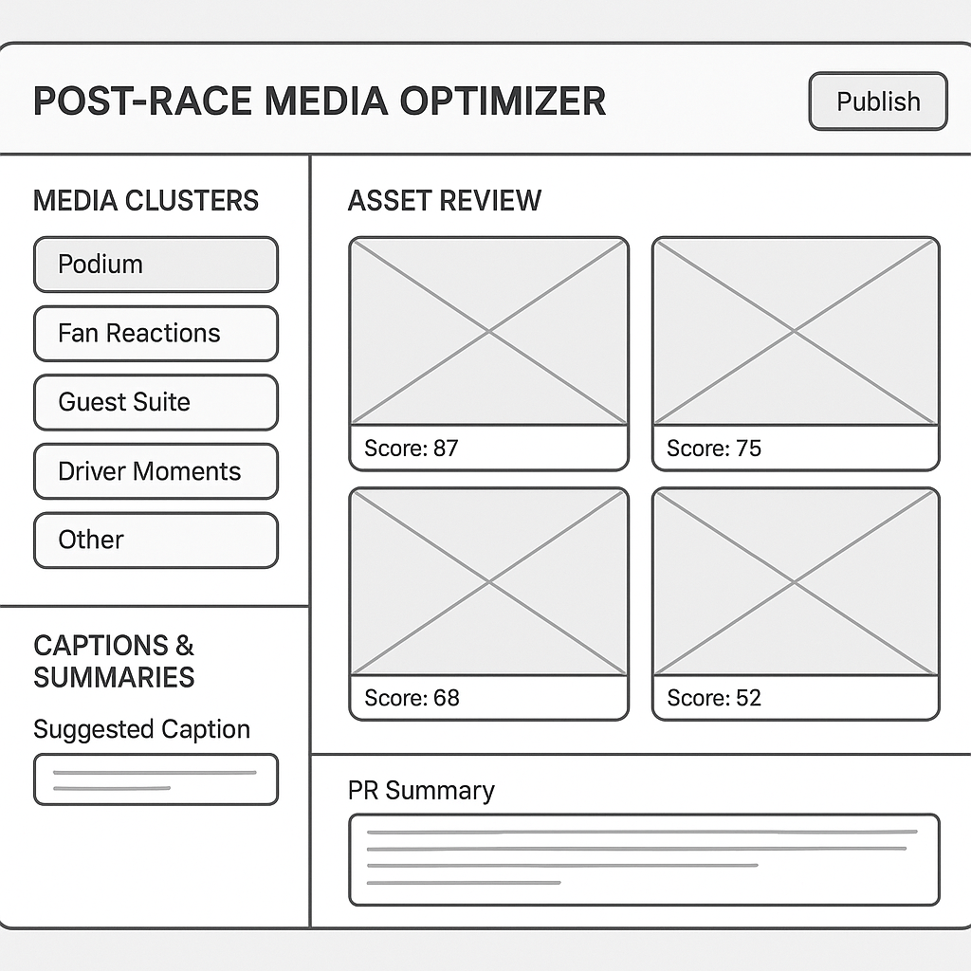
Wireframe Diagram of AI-ML / Gen AI Powered Post-Race Media Optimiser

Indicative Timeline (12 Weeks / ~3 Months):
- Month 1: Discovery + Media AI Layer kick-off + Sponsor/logo detection, clustering, NLP integration.
- Month 2: Scoring, Ranking, GenAI copywriting.
- Month 2-3: Publishing integrations + UI console.
- Month 3: Testing, deployment, monitoring.

Gantt Chart for AI-ML / GenAI Powered Post-Race Media Optimiser
JTR AI-Study Project Development Phases & Timelines
Weeks | 1 | 2 |  | 3 |  | 4 |  |  | 5 |  | 6 |  |  | 7 |  |  | 8 |  | 9 |  | 10 | 11 |  | 12
Phases
Phase 1: Discovery & Input Stream Setup | 1 | 0 |  | 0 |  | 0 |  |  | 0 |  | 0 |  |  | 0 |  |  | 0 |  | 0 |  | 0 | 0 |  | 0
Phase 2: Media Processing AI Layer | 0 | 1 |  | 1 |  | 0 |  |  | 0 |  | 0 |  |  | 0 |  |  | 0 |  | 0 |  | 0 | 0 |  | 0
Phase 3: Asset Scoring & Ranking | 0 | 0 |  | 1 |  | 1 |  |  | 1 |  | 0 |  |  | 0 |  |  | 0 |  | 0 |  | 0 | 0 |  | 0
Phase 4: GenAI Copywriting Layer | 0 | 0 |  | 0 |  | 0 |  |  | 1 |  | 1 |  |  | 0 |  |  | 0 |  | 0 |  | 0 | 0 |  | 0
Phase 5: Integration with Publishing Tools | 0 | 0 |  | 0 |  | 0 |  |  | 0 |  | 1 |  |  | 1 |  |  | 0 |  | 0 |  | 0 | 0 |  | 0
Phase 6: UI Console Development | 0 | 0 |  | 0 |  | 0 |  |  | 0 |  | 0 |  |  | 1 |  |  | 1 |  | 0 |  | 0 | 0 |  | 0
Phase 7: Testing & QA | 0 | 0 |  | 0 |  | 0 |  |  | 0 |  | 0 |  |  | 0 |  |  | 1 |  | 1 |  | 1 | 0 |  | 0
Phase 8: Deployment & Monitoring | 0 | 0 |  | 0 |  | 0 |  |  | 0 |  | 0 |  |  | 0 |  |  | 0 |  | 0 |  | 1 | 1 |  | 1

Link to above Gantt chart:

Considerations

- The scope for developing and implementing the Post-Race Media Optimiser is to expire no earlier than the conclusion of Season 12 of the ABB FIA Formula E World Championship. At this point, TCS and Jaguar TCS Racing can extend the terms of this scope to a later date.
- Following the conclusion of Season 12 of the ABB FIA Formula E World Championship, TCS and Jaguar TCS Racing will review the efficacy of the Post-Race Media Optimiser tool to identify future usability and potential evolution of the tool for Season 13.
- The scope of this project falls within the remit of the Jaguar TCS Racing commercial team and is therefore exempt from cost cap regulations. As such, its delivery must comply with the following requirement: the tool must be developed using JLR-issued devices in order to successfully migrate the tool to the end users.
- IP ownership – all IP in the tool will be [jointly] owned with licensing arrangements in place for the parties to use it.

Budget
- All costs associated with the development, delivery, implementation and optimisation of this project will be at TCS’ expense. This includes but is not limited to any consultancy fee; and any cost associated with the development and implementation of the Post-Race Media Optimiser tool.
- All ongoing monitoring, maintenance and optimisation costs associated with the project once the Post-Race Media Optimiser tool has been embedded will be at TCS’s expense.

Confidential Information and Intellectual Property
All information and IP disclosed between the parties during this project remains in the ownership of the disclosing party and is confidential information for the purposes of clause 17 of the Sponsorship Agreement. As such, the confidential information must not be divulged to any other person and cannot be used other than for the purpose of developing and implementing the technical product, and consultancy opportunities thereafter.
The development of the Post-Race Media Optimiser tool will be under embargo until the tool has been developed, approved and embedded within the Jaguar TCS Racing commercial team. Following the development of the tool, TCS and Jaguar TCS Racing will agree on the messaging that will be used to talk about the project.
The tool development stage of the project will be deemed to have concluded once TCS has successfully integrated the tool within the Jaguar TCS Racing commercial team. Following this, the embargo on this project will lift and both parties will have permission to talk publicly about the project in its entirety using the pre-agreed messaging, subject to racing sensitivities.
At this point, TCS will monitor and optimise the tool following implementation. Jaguar TCS Racing and TCS can assess the terms including the IP position and relevant wording for any clauses as required. During the tool development phase, there is no obligation on either party to proceed with the proposed solution and remains subject to written agreement between the parties.

